**Evidence for Analysis and Design Unit.**

Ryan Forgie

Cohort 15

2017

**AD - 1 Use case Diagram**

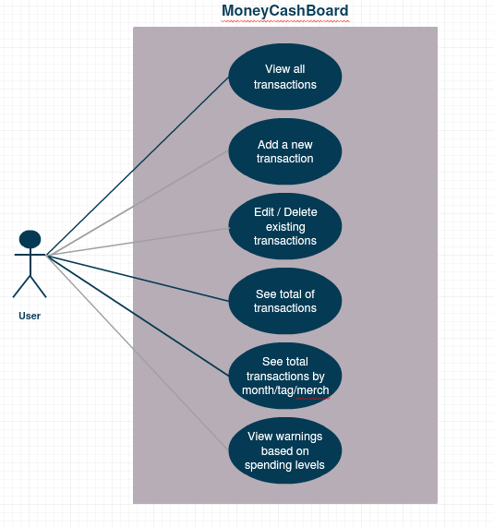

**AD - 2 Create a Class diagram using your Use case diagram.**

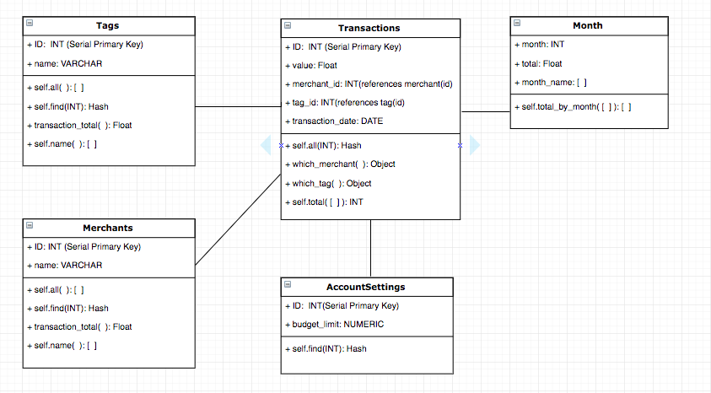

**AD - 3 Object diagram**

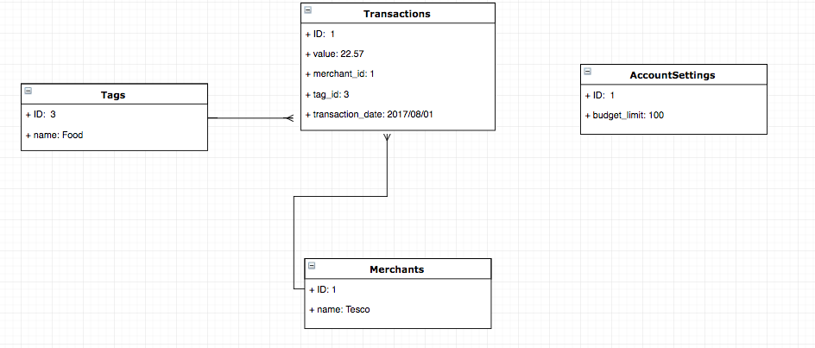

**AD - 4 Activity diagram**

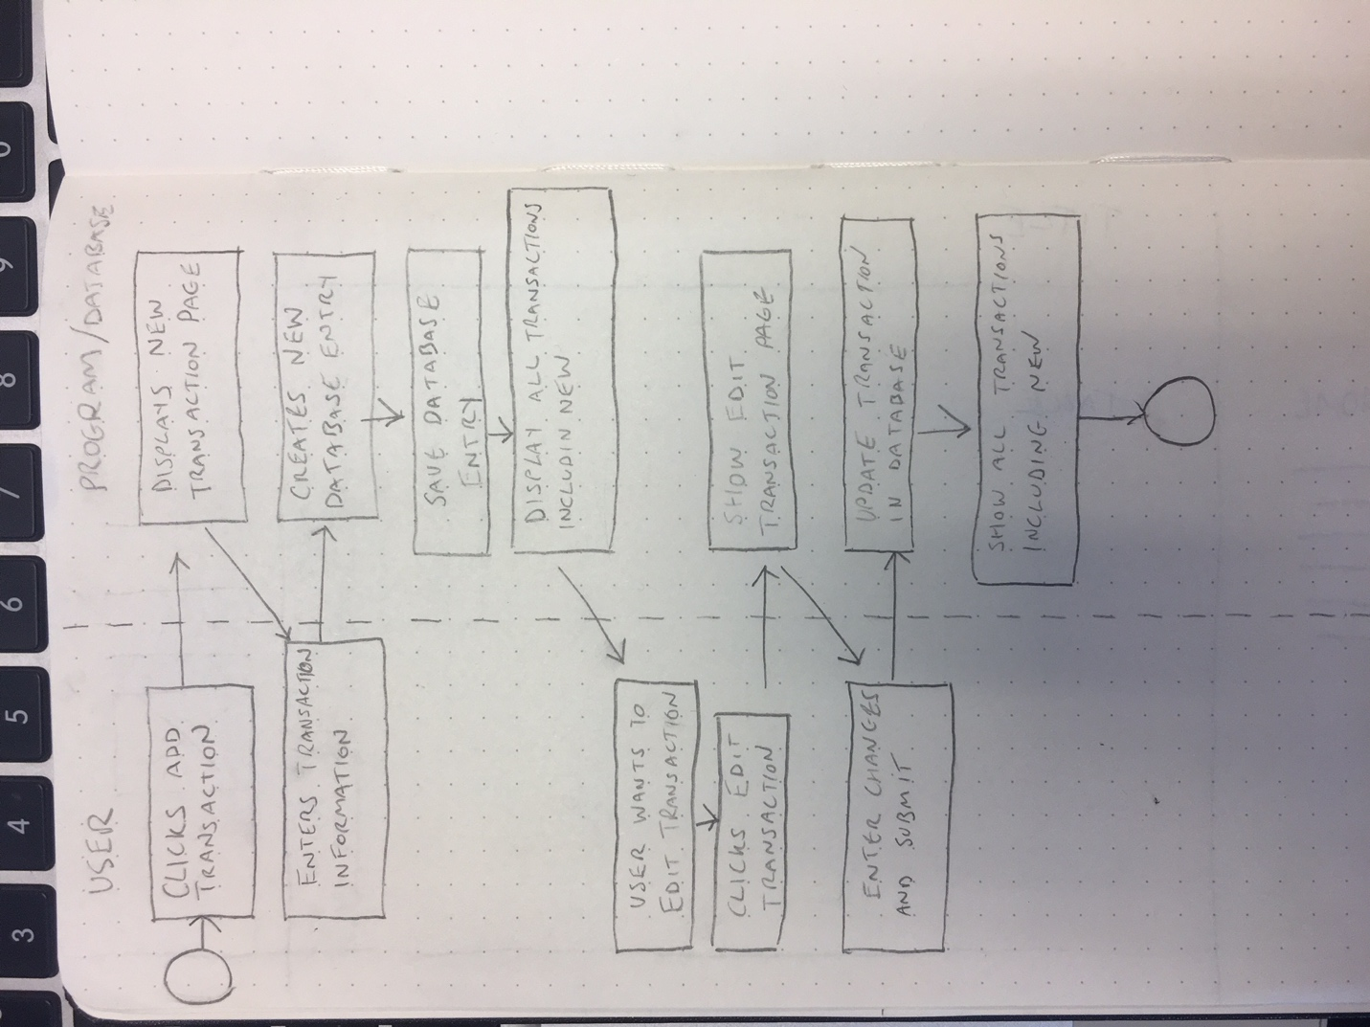

**AD - 5 Inheritance diagram**

**?**

**AD - 6 Implementations Constraints**

|  |  |  |
| --- | --- | --- |
| Constraints | Possible Effect of Constraint | Details |
| Hardware and software Platforms | Website is not responsive so will not display correctly on different sized screens/mobile devices. Has only been tested in Google Chrome so may have display issues on other browsers | Implement responsive design from the beginning of project and also carry out CSS testing to ensure website has compatibility with all major browsers. |
| Performance requirements | The current app can only track once account and has no support for setting budgets for individual months, tags and merchants. All of these are features that would incentivize user to actually use the app | Implement multiple account management with separate budget setting for individual accounts and for months/tags/merchants. |
| Persistent storage and transactions | Website will slow down significantly once enough transactions are saved. Also the All Transactions table will become unmanageably large once a year’s finances are entered. | Make the All Transactions table dynamic and filterable so that it displays a manageable amount of transactions at one time. |
| Budgets | No budget used in this project | Personal project for the course at Codeclan |
| Time | Given the one week timeframe there was not much time to add additional features outside of the given brief. I did not allocate enough time to making the site responsive or include this in my plan from the beginning. | Allocate more planning time to front end, particularly responsive aspect. Continue work on project at a later date to learn more from it. |